Clinical Information Pack

Clinical Lecturer

|  |  |  |  |
| --- | --- | --- | --- |
| Post title: | **NIHR Clinical Lecturer in General Psychiatry** | | |
| Schools: | Clinical and Experimental Sciences | | |
| Faculty: | Faculty of Medicine (FoM) | | |
| Career Pathway: | Clinical | Level: | *AMNL/CADT |
| Salary: AMNL scale | £44,159 | To | £76,280 |
| Salary: CADT scale | £61,825 (ST3/CT3 to ST5) | To | £70,425 (ST6 to ST8) |
| Associated NHS bodies | Hampshire and Isle of Wight Healthcare NHS Foundation Trust | | |
| Clinical category: | Balanced portfolio | | |
| Posts responsible to: | Professor of Psychiatry | | |
| Posts responsible for: | Research Staff and Postgraduate Research Students as appropriate | | |

**Particulars of Appointment**

The Faculty of Medicine wishes to appoint an NIHR Academic Clinical Lecturer in General Psychiatry or Primary Care.

The post is intended for an applicant who is in medical training within General Psychiatry or an applicant from Primary Care, with the specialty of the final (single) post dependent on the successful applicant.

The applicant will have a higher research degree (or have submitted for such a degree at the time of application) and appropriate research experience.

The post is subject to terms and conditions of service determined by the University of Southampton and in its honorary clinical capacity by the Hampshire and Isle of Wight Healthcare NHS Foundation Trust.

**This pack sets out the details for the post as it would be linked to General Psychiatry.**

The post-holder will be pursuing their development of research and teaching within the Clinical Neuroscience Section of the School of Clinical and Experimental Sciences, within the Faculty of Medicine, University of Southampton.

In this post-doctoral role, the successful candidate will have substantial experience of the relevant research areas, a proven track record of high-quality original research publications, the ability to work well in a multidisciplinary, multi-professional team and hold a corresponding NTN.

**The University of Southampton**

The University of Southampton is a leading research-intensive University, a member of the Russell Group and one of the top 100 universities worldwide. We deliver an excellent educational experience, world-leading research and we are known for successfully commercialising that research through enterprise.

This is an exciting time to join the University of Southampton. We have an aspirational University Strategy (see [www.southampton.ac.uk/strategy](http://www.southampton.ac.uk/strategy)), setting out our ambitions over the next five years. The strategy involves achieving a top 10 place in the UK for research, which we will achieve by investing in the highest quality staff and facilities. We are also transforming the education offer available to undergraduate and postgraduate students across the University, providing greater flexibility and modular courses, with a strong international focus.

**The Faculty of Medicine**

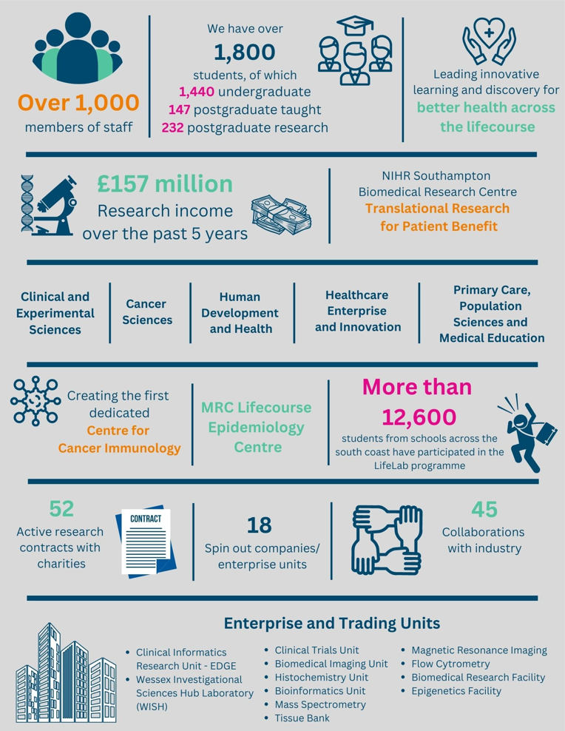

The creation of the Faculty of Medicine has enabled us to build upon strong foundations of basic research and clinical translation.  Working with colleagues across the University and in the local NHS we have strengthened our position as a renowned centre for translational research, leading innovative learning and discovery for better health across the life-course.  In this context, we are looking to appoint an outstanding senior academic to develop and lead a major programme of funded clinical research in the field of interstitial lung disease.

Key to the success of the Faculty of Medicine is the delivery of high-quality education for undergraduate and postgraduate students, building on our partnership in biomedical research with University Hospital Southampton NHS Foundation Trust and fostering new collaborations with the physical sciences, including chemistry, engineering and computing. The new senior academic in respiratory medicine will play a key role in these developments.

The Faculty celebrated its 40th anniversary in 2016. In 1971 FoM consisted of 40 students. FoM is now reputed for its excellence in research, innovative clinical teaching and is a vibrant pillar of the South of England community.

**The Student Experience**

We offer a range of undergraduate programmes: the BM4 programme, a graduate-entry four-year programme which accepts 48 students per year; and the BM5 and BMedSc programme which accepts 200 students per year including approximately 30 students from a BM6 programme aimed at widening access to a medical career. Students also join the first two years for teaching in Southampton on the BM(EU) Programme, an affiliation with a German Medical school in Kassel. Biomedical/ Psychosocial Teaching in the first two years of the BM programmes is delivered in the South Block of Southampton General Hospital as well as on Highfield campus. Clinical teaching takes place at Southampton General Hospital and the adjoining Princess Anne Hospital, the Royal South Hants Hospital, and in NHS Trusts and General Practices throughout Hampshire, Dorset, West Sussex and Salisbury.

The BM5 programme has a number of distinctive features.   These include the integrated nature of teaching where the scientific disciplines are taught together in a clinical context using a systems-based approach and the BMedSc programme, a four-month supervised research project undertaken in Year 3. There is also the opportunity, for selected students, to undertake an integrated, intercalated Masters in Medical Science (MMedSc).  The BM4 programme also has several key features.  These include clinical topics in the first two years where students meet on a regular basis in Graduate Groups and learning with BM5 students in the third and fourth years on all clinical attachments.  All students take the same final examinations.  All programmes have substantial clinical experience in the first two years, student selected components, dispersed final year attachments, work shadowing prior to commencing a Foundation post and inter-professional learning.

In addition to the undergraduate BM programmes the School provides four Masters Degree programmes in Public Health, Allergy, Genomics and Diabetes plus an MRres.

**Research and Enterprise**

The Faculty of Medicine has a clear research strategy to investigate the biomedical basis of common human diseases and to translate this into clinical practice. All research undertaken within the Faculty has clear evidence of international excellence and is delivered through appropriate Faculty Schools.

The Faculty of Medicine Enterprise Strategy is fully aligned to the University Enterprise Strategy to provide a step change to its enterprise and innovation culture, delivering global outreach, community engagement, innovative healthcare and policy. We work with all stakeholders from industry and pharma to health providers and the community.

**Equality, Diversity and Inclusivity**

We are committed to positively advancing equality of opportunity. We participate in a number of equality initiatives which celebrate good employment practice for the advancement of diversity, equality and inclusivity. These include the Stonewall Workplace Equality Index, the Race Equality Charter and Athena Swan, (for which we are currently silver award holders). We also have a number of staff equality committees who champion the advancement of equalities for diverse groups.



**Southampton Behaviours**

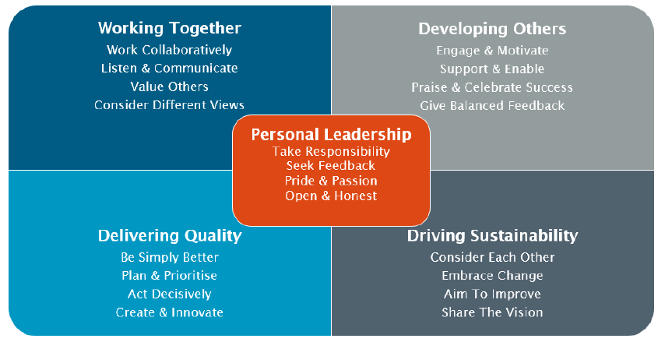

**School Information**

**Clinical and Experimental Sciences (CES)**

Our research spans numerous clinical areas, including major human infectious diseases and diseases that affect the central nervous system, eyes, gastrointestinal tract, joints, liver, lungs, skin and urogenital tract. We focus on important common chronic inflammatory conditions such as age-related macular degeneration, allergy, asthma, chronic obstructive pulmonary disease, Crohn's disease, psoriasis, and rheumatoid arthritis, and on psychiatric illness including affective disorders, alcohol use disorders, impulsive-compulsive disorders, and neurodegenerative conditions such as Alzheimer's disease and Lewy Body dementia.

Our key strengths include our ability to exploit cross-cutting themes and to study disease mechanisms from the molecular level to the whole patient. We conduct clinical trials, with both commercial and non-commercial partners, where insights from basic science in the laboratory are now underpinning novel treatments, gene therapies and stem cell research. We value cross-disciplinary and industrial collaborations that promote ‘joined-up thinking' to support and accelerate our research progress, through access to novel expertise and technologies.

There is comprehensive provision for clinical and translational research in Southampton: This includes an NIHR accredited Clinical Trials Unit, the Wessex Clinical Research Network for late phase trials, the Cancer Research UK Clinical Research Unit for early phase trials, the Southampton Experimental Medicine Cancer Centre to support translational research, and the NIHR Biomedical Research Facility.

Specific to General Psychiatry, there are existing strong partnerships with Hampshire and Isle of Wight Healthcare NHS Foundation Trust, which hosts both the Mood Disorders Service (supported by the Office of Life Sciences Mental Health Mission) and the Southern Gambling Service (supported by NHS England and covering six Integrated Care Board territories using largely digital approaches).

Academic Psychiatry brings together a critical mass of clinical and non-clinical researchers to explore areas of common interest centred on important mental health problems. The Department of Psychiatry conducts impactful work on research, education, policy, and practice, to enhance understanding of the causes of a range of mental health conditions, increase their recognition, evaluate potential novel treatments, and promote better evidence-based treatments and care pathways. Current research areas include: behaviourally addictive disorders (Chamberlain; ~£740k per annum permanent NHS funding; leads ARC Wessex Mental Health workstream, ~£1million NIHR funding); alcohol use disorders (Sinclair; NIHR funding for evaluation of alcohol care teams); mood and anxiety disorders (Baldwin: funding from Office of Life Sciences Mental Health Mission, and NIHR for studies in treatment-resistant depression); neuropsychopharmacology (Hou: investigations of locus coeruleus structure and function, and psychoneuroimmunology)); neuroinflammation and neurodegeneration (Amin: studies of dementia and blood-brain barrier permeability); and experimental medicine models of anxiety and placebo/nocebo response (Baldwin, Huneke). Affiliated researchers from Psychology bring additional leading expertise in attention-deficit hyperactivity disorder (ADHD) (Cortese, Parlatini). Academic Psychiatry is part of large national and international collaborative projects, such as the EU Horizon Bootstrap study (EUR7,500,000) that is developing and deploying innovative digital treatments to address problematic usage of the internet in young people, as well as a study focusing on mental health in university students (£3,858,309 UKRI).

**Hampshire and Isle of Wight Healthcare NHS Foundation Trust**

HIOW Healthcare NHS Foundation Trust is one of the largest Foundation Trusts in the UK, specialising in mental health, adult and child community health, and learning disabilities. The trust’s vision is to transform the delivery of care across Hampshire and the Isle of Wight by creating a sustainable care system working closely with acute trusts, social services and emerging primary care consortia to develop an integrated neighbourhood working approach. The Trust also provides specialist mental health services to a wider population in southern England via NHS specialist services commissioning arrangements. These include adolescent in-patient services, perinatal mental health care, and adult and adolescent forensic services. The trust provides NHS psychological therapies for Hampshire. The Trust has a positive working relationship with the University of Southampton and an active programme of Research and Innovation. It is committed to education of healthcare professionals.

**Post information**

The University Department of Psychiatry has 4 professors, 1 associate professor (Dr Amin), 1 clinical lecturer (Dr Huneke), 5 academic clinical fellows, 6 psychiatry doctoral students, and 12 research staff, The Programme Leads for General Psychiatry are Professor David Baldwin, Professor Sam Chamberlain, and Professor Julia Sinclair. There are close links with the School of Psychology which employs two clinical academics in Child and Adolescent Psychiatry (Professor Cortese and Associate Professor Valeria Parlatini).

Opportunities include joining funded work at the University of Southampton and Hampshire and Isle of Wight Healthcare NHS Foundation Trust, including research into affective disorders, alcohol use disorders, impulsive-compulsive disorders, and behavioural addictions (such as gambling disorder).

Additional research opportunities would include those building upon areas of methodological expertise elsewhere in the Faculty of Medicine and within the School of Psychology, including clinical and experimental psychopharmacology, cognitive evaluation, endophenotype identification, meta-analysis, qualitative and mixed-methods research, and neuroimaging.

Clinical training is tailored to the requirements of the trainee and may include training at other centres. Locally the clinical supervisor will be one of the research active psychiatry consultants. The clinical timetable would be tailored to the training needs of the post-holder.

**Faculty staff in Psychiatry**

Section Head, Clinical Neuroscience: Professor David Baldwin

Head of University Department: Professor Sam Chamberlain

Deputy Head of University Department: Professor Julia Sinclair, Addiction Psychiatry

Professor Samuele Cortese, Child and Adolescent Psychiatry

Professor Ruihua Hou, Biological Psychiatry

Associate Professor Jay Amin, Psychiatry of Older Age

Associate Professor Valeria Parlatini, Child and Adolescent Psychiatry

NIHR Clinical Lecturer: Dr Nathan Huneke, General Psychiatry

Job Description and Person Specification

|  |
| --- |
| Job purpose |
| To undertake research in accordance with specific research projects under supervision (0.5 FTE); and to undertake clinical duties as a Specialty Trainee (0.5 FTE) |

|  |  |  |
| --- | --- | --- |
| Key Research accountabilities | | % Time |
|  | |  | | --- | | To develop and carry out an area of personal research. | | To disseminate findings in peer-reviewed journals, and present results at scientific conferences. | | To contribute to the writing of bids for research funding. | | Carry out administrative tasks associated with specified research funding, for example risk assessment of research activities, organisation of project meetings and documentation. Implementation of procedures required to ensure accurate and timely formal reporting and financial control. | | 35% or more |
|  | Key Education accountabilities |  |
|  | |  | | --- | | As a member of a teaching team within an established programme of study, support the teaching objectives of the Faculty/School/Department by delivering teaching to students at undergraduate and/or postgraduate level, through allocated lectures, tutorials, and seminars. | | Directly supervise students, providing advice on study skills and helping with learning problems. Identify the learning needs of students and define learning objectives. Set and mark coursework and exams, providing constructive feedback to students. |  |  | | --- | | Develop own teaching materials, methods and approaches, with guidance. Obtain and analyse feedback on own teaching design and delivery. | | Continually update own knowledge and understanding of subject area, incorporating knowledge of advances into own teaching contributions. | | 10% |

|  |  |  |
| --- | --- | --- |
|  | Key Management, Leadership and Engagement accountabilities |  |
|  | Contribute to the efficient management and administration of the School/PCRC by performing personal administrative duties as allocated by the Section Head (Professor David Baldwin). | 5% |
| Key Clinical accountabilities | | % Time |
| Clinical academic staff are managerially accountable for their clinical duties to the designated Clinical Lead for the relevant specialty within Hampshire and Isle of Wight Healthcare NHS Foundation Trust (and successor organisations).  On-call Arrangements. The exact nature of any on-call commitments to be undertaken will be agreed within a jointly agreed Job Plan. | | 50% |

| Internal and External Relationships |
| --- |
| May have additional reporting and liaison responsibilities to external funding bodies or sponsors. Working with collaborators/colleagues in other work areas and institutions.  New appointees will be assigned a senior colleague to guide their development and aid their integration into the Department/School/Faculty/University.    Teaching and administrative duties will be allocated by the Section Head/Head of Department, within the context of the teaching programmes.  Other key relationships:   * Research colleagues in CES, School of Psychology and School of Biological Science * Research colleagues in ARC Wessex and Southampton Biomedical Research Cenre * Clinical colleagues in Hampshire and Isle of Wight Healthcare NHS Foundation Trust * Central University Offices/Professional Services (e.g. Graduate Office, Finance, Research and Innovation services etc.); |

| Staff Benefits |
| --- |
| Working at the University of Southampton gives you access to a wide range of benefits in addition to our competitive rates of pay. Our core benefits include pension scheme membership; a generous annual leave allowance (supplemented by University closure days and public holidays) and excellent family leave arrangements (including maternity, paternity, adoption and parental leave).   * Faculty Mentoring Scheme; * Ability to remain in NHS pension scheme, subject to qualifying criteria; * Discounted Sport and Wellbeing membership; * Access to private dental and/or healthcare insurance; * Cycle to work scheme * Tax-Free childcare |

**Person Specification**

|  |  |  |  |
| --- | --- | --- | --- |
| Criteria | Essential | Desirable | How to be assessed |
| Qualifications, knowledge and experience | Medical degree  GMC registration  MRCPsych or equivalent  In General Psychiatry specialty clinical training and appointable to NTN or hold NTN alreadyST3 or above  Evidence of commitment to a clinical academic career  Evidence of ability to undertake statistical analysis through competence in use of statistical analysis software  PhD/MD (or equivalent) in mental health research. The applicant must have submitted their PhD or MD thesis at the time of application, and the higher research degree must be awarded before commencing post.Experience of undergraduate/postgraduate medical teaching | Experience in conducting a systematic review and meta-analysis  Experience in research into sleep disorders and perinatal mental health problems  Experience in design of longitudinal research  Experience of partnerships with PPIE representatives or organisations | CV/interview |
| Planning and organising | Ability to organise own research activities to deadlines and standards |  | CV/Interview |
| Problem solving and initiative | Ability to develop understanding of complex problems and apply in-depth knowledge to address them |  | CV/interview |
| Management and teamwork | Work effectively in a team, understanding strengths and weaknesses of others | Ability to work in a multi-professional team | CV/interview |
| Communicating and influencing | Communicating new and complex information effectively, both verbally and in writing, engaging the interest and enthusiasm of the target audience  Ability to present research results at group meetings and conferences  Track record of original publications in leading peer-reviewed journals  Work proactively with colleagues in other work areas/institutions, contributing specialist knowledge to achieve outcomes | National/ international research award(s) | CV/interview |
| Other skills and behaviours | Positive attitude to colleagues and students. |  | CV/interview |
| Special requirements | Able to work clinically at the level of a Specialty Trainee in General Psychiatry  Able to attend national and international conferences to present research results | To be on a Speciality training programme in General Psychiatry  Experience of presenting at national and international conferences | CV/interview |

**JOB HAZARD ANALYSIS**

**Is this an office-based post?**

|  |  |
| --- | --- |
| Yes | If this post is an office-based job with routine office hazards (eg: use of VDU), no further information needs to be supplied. Do not complete the section below. |
| No | If this post is not office-based or has some hazards other than routine office (eg: more than use of VDU) please complete the analysis below.  Hiring managers are asked to complete this section as accurately as possible to ensure the safety of the post-holder. |

## - HR will send a full PEHQ to all applicants for this position. Please note, if full health clearance is required for a role, this will apply to all individuals, including existing members of staff.

|  |  |  |  |
| --- | --- | --- | --- |
| **ENVIRONMENTAL EXPOSURES** | **Occasionally**  (<30% of time) | **Frequently**  (30-60% of time) | **Constantly**  (> 60% of time) |
| Outside work |  |  |  |
| Extremes of temperature (eg: fridge/ furnace) |  |  |  |
| ## Potential for exposure to body fluids | √ |  |  |
| ## Noise (greater than 80 dba - 8 hrs twa) |  |  |  |
| ## Exposure to hazardous substances (eg: solvents, liquids, dust, fumes, biohazards). Specify below: |  |  |  |
| Frequent hand washing |  |  |  |
| Ionising radiation |  |  |  |
| **EQUIPMENT/TOOLS/MACHINES USED** | | | |
| ## Food handling |  |  |  |
| ## Driving university vehicles(eg: car/van/LGV/PCV) |  |  |  |
| ## Use of latex gloves (prohibited unless specific clinical necessity) | √ |  |  |
| ## Vibrating tools (eg: strimmers, hammer drill, lawnmowers) |  |  |  |
| **PHYSICAL ABILITIES** | | | |
| Load manual handling |  |  |  |
| Repetitive crouching/kneeling/stooping |  |  |  |
| Repetitive pulling/pushing |  |  |  |
| Repetitive lifting |  |  |  |
| Standing for prolonged periods |  |  |  |
| Repetitive climbing (ie: steps, stools, ladders, stairs) |  |  |  |
| Fine motor grips (eg: pipetting) |  |  |  |
| Gross motor grips |  |  |  |
| Repetitive reaching below shoulder height |  |  |  |
| Repetitive reaching at shoulder height |  |  |  |
| Repetitive reaching above shoulder height |  |  |  |
| **PSYCHOSOCIAL ISSUES** | | | |
| Face to face contact with public | √ |  |  |
| Lone working | √ |  |  |
| ## Shift work/night work/on call duties |  |  |  |